



**Objective :** To understand image compression by lossless technique (Run Length Coding).



# Expected Outcome of Experiment :

| **Course Outcome** | **Description** |
| --- | --- |
| **CO-5** | Design and develop applications based on 1-D and 2-D digital signals. |



**Books / Journals / Websites referred :**

* <http://www.mathworks.com/support/>
* [www.math.mtu.edu/~msgocken/intro/intro.html](http://www.math.mtu.edu/~msgocken/intro/intro.html)
* [www.mccormick.northwestern.edu/docs/efirst/matlab.pdf](http://www.mccormick.northwestern.edu/docs/efirst/matlab.pdf)
* A.Nagoor Kani “Digital Signal Processing”, 2nd Edition, TMH Education.



# Pre-Lab Prior concepts :

Variable length code can be used to remove coding redundancy. One of the way to remove the inter pixel redundancy is run length coding. When inter pixel redundancy is removed by using run length coding the mapper transforms the input data in to usually non visual format. This operation is reversible and may or may not reduce directly the amount of data required to represent the image. Run length coding is the example of a mapping that directly results in data compression in the initial stage of overall source encoding process.



# Implementation Steps with Screenshots:

**CODE:**  
  
filename = input('Enter the image filename with extension: ', 's');

img_matrix = imread(filename);

img = reshape(img_matrix, 1, []);

count = 1;

encoded = [];

for i = 2:length(img)

if img(i) == img(i-1)

count = count + 1;

else

encoded = [encoded img(i-1) count];

count = 1;

end

end

encoded = [encoded img(end) count];

decoded = [];

for i = 1:2:length(encoded)

val = encoded(i);

cnt = encoded(i+1);

for j = 1:cnt

decoded = [decoded val];

end

end

decoded_matrix = reshape(decoded, size(img_matrix));

subplot(1,2,1);

imshow(img_matrix);

title('Original Image');

subplot(1,2,2);

imshow(decoded_matrix);

title('Decoded Image');

**OUTPUT:**

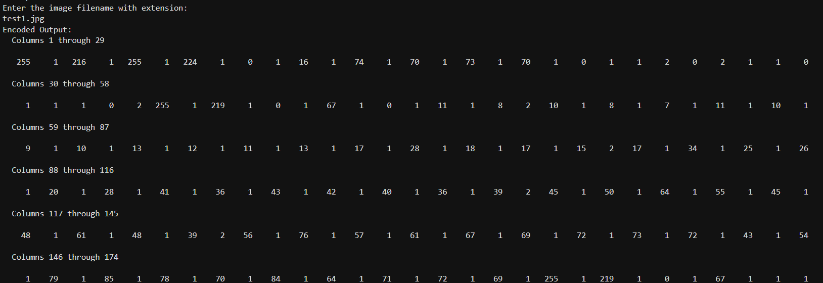

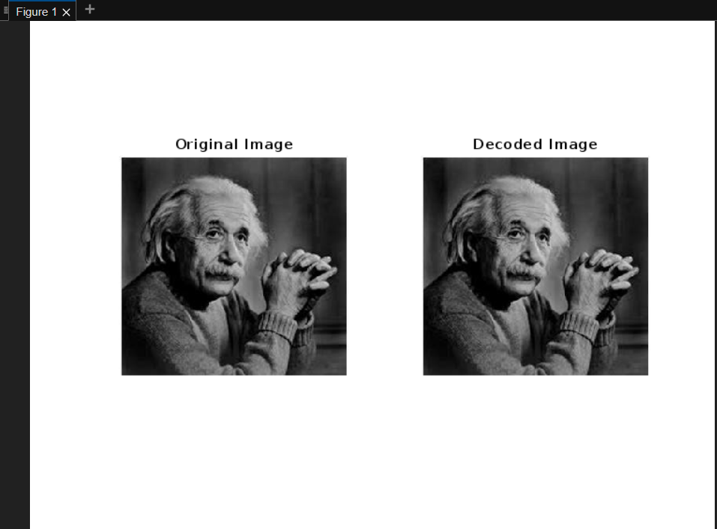



**Conclusion :**

RLC was manually implemented, showing effective image compression by reducing pixel redundancy without any data loss or quality degradation.

**Post-Lab Questions :**

**Compare Lossy and lossless compression.**

**Answer:**

| **Feature** | **Lossy Compression** | **Lossless Compression** |
| --- | --- | --- |
| **Data Restoration** | Cannot restore original data exactly | Can restore original data exactly |
| **Compression Ratio** | Higher | Lower |
| **Quality** | May reduce quality | Retains original quality |
| **Examples** | JPEG, MP3, MP4 | PNG, GIF, ZIP |
| **Use Cases** | Multimedia (images, audio, video) | Text, medical images, technical data |
| **Technique Used** | Irrelevant data discarded | Redundant data encoded efficiently |

# Date: Signature of faculty In-charge